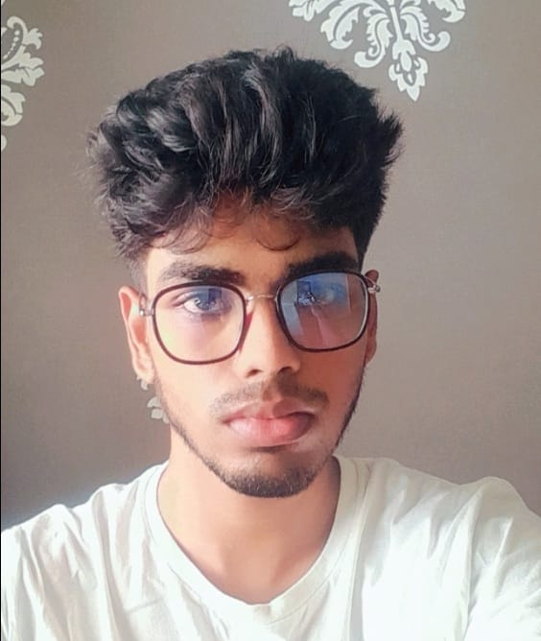

# Dhanush G

### 

**19B,Annai Theresa Nagar,Chennai**

**dhanushg0902@gmail.com**

**9677017942**

### 

OBJECTIVE

To get an opportunity that allows me to showcase my skills and contribute to the company’s growth.

EDUCATION

**Rajalakshmi Engineering College, October 2020 - May 2024**

Bachelor of Engineering in Computer Science

CGPA: 8.62

PROJECTS

* Skill analysis using Angular (ms server via springboot)
* Music genre recognition using Machine learning
* Rock,paper,scissors using python (so called)

SKILLS

* Python
* Angular
* C

AREA OF INTERESTS

* Data analysis
* UI/UX Design
* Machine learning

LANGUAUGES

* English
* Tamil